

**Hotel Management System**

**(Use case Analysis)**

**Project Number:**

**Group # 9**

**Submitted To:**

**Mam Sadaf Naeem**

**Project Team**

|  |  |  |  |  |  |
| --- | --- | --- | --- | --- | --- |
| **List** | **Roll #** | | **Names** | | **Contribution** |
| 1 | | 231400032 | | Alishba Kiran | Migration |
| 2 | | 231400033 | | Ehtasham Maqbool | 40% |
| 3 | | 231400038 | | M. Bilal | 35% |
| 4 | | 231400126 | | Afaq Hussain | 25% |

**Submission Date**

**Jan 12, 2025**

**Table of Contents**

**1.** **UCD** 1

**2.** **Use case Scenarios** 1

**3. Prototype** 1

**4. References** 1

# **UCD**

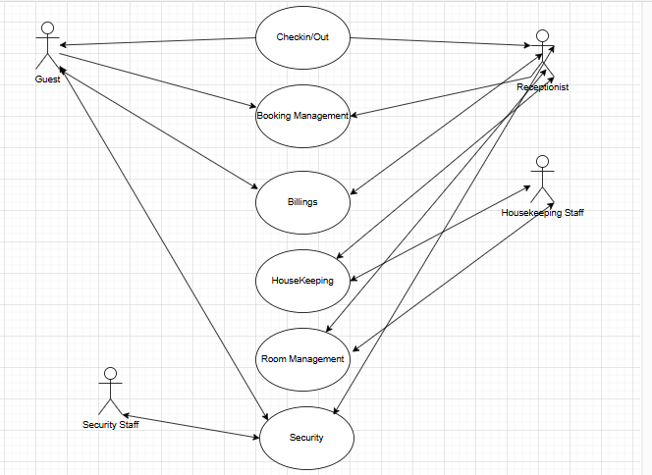

# **Use case Scenarios**

**Detailed Use Case Scenarios**

#### 

* **UC ID:** UC-01

### **UC Name:** Guest Check-In/Out

**Primary Actor:** Guest  
**Secondary Actor:** Receptionist

### **Pre-Conditions:**

1. Guest must have a confirmed booking.
2. The receptionist system must be operational.

### **Post-Conditions:**

1. The room status is updated.
2. The guest receives a check-in or check-out confirmation.

### **Flow of Events:**

|  |  |
| --- | --- |
| User Action | System Response |
| |  | | --- | | 1. Guest provides booking ID or identification to the receptionist. | | |  | | --- | | 1. Guest provides booking ID or identification to the receptionist. | |
| |  | | --- | | 2. Receptionist assigns a room (for check-in) or generates the bill (for check-out). | | |  | | --- | | 2. Receptionist assigns a room (for check-in) or generates the bill (for check-out). | |
| |  | | --- | | 3. Guest receives a confirmation of check-in or check-out. | | |  | | --- | | 3. Guest receives a confirmation of check-in or check-out. | |

**UC ID: UC-02**

### **UC Name: Booking Management**

**Primary Actor:** Guest  
**Secondary Actors:** Receptionist, Booking System

### **Pre-Conditions:**

1. The system must be operational.
2. Room availability must be verified.

### **Post-Conditions:**

1. Booking details are stored.
2. A confirmation is sent to the guest.

### **Flow of Events:**

| **User Action** | **System Response** |
| --- | --- |
| 1. Guest provides booking details (dates, preferences). | 1. System checks availability and calculates the total cost. |
| 2. Guest confirms the booking. | 2. System generates a booking confirmation. |
| 3. Receptionist confirms the booking details. | 3. System saves the booking and sends a confirmation to the guest. |

* **UC ID: UC-03**

### **UC Name: Billing**

**Primary Actor:** Guest  
**Secondary Actor:** Receptionist

### **Pre-Conditions:**

1. All guest services (e.g., minibar, room service) must be recorded in the system.

### **Post-Conditions:**

1. Payment is processed, and an invoice is generated.

### **Normal Flow of Events:**

| **User Action** | **System Response** |
| --- | --- |
| 1. Guest requests a bill for services. | 1. System retrieves and calculates charges. |
| 2. Guest reviews and makes a payment. | 2. System processes the payment and generates an invoice. |
| 3. Guest receives the invoice. | 3. System logs the transaction. |

* **UC ID: UC-04**

### **UC Name: Housekeeping**

**Primary Actor:** Housekeeping Staff  
**Secondary Actor:** Receptionist

### **Pre-Conditions:**

1. The system must track room statuses.

### **Post-Conditions:**

1. Room status is updated to "Available" after cleaning.

#### **Normal Flow of Events:**

| **User Action** | **System Response** |
| --- | --- |
| 1. Receptionist updates the room status to "Requires Cleaning." | 1. System logs the request and notifies housekeeping. |
| 2. Housekeeping staff cleans the room. | 2. System allows staff to update the status to "Ready." |
| 3. Room is marked as available. | 3. System updates the status to "Available." |

#### 

* **UC ID: UC-05**

### **UC Name: Room Management**

**Primary Actor:** Receptionist  
**Secondary Actor:** Housekeeping

### **Pre-Conditions:**

1. Guest must have a booking.
2. System must track room availability.

### **Post-Conditions:**

1. Room status is updated to "Occupied."

### **Normal Flow of Events:**

| **User Action** | **System Response** |
| --- | --- |
| 1. Receptionist assigns a room to a guest. | 1. System updates room status. |
| 2. Housekeeping prepares the room. | 2. System allows staff to mark the room as "Ready." |
| 3. Guest checks in. | 3. System updates room status to "Occupied." |

* **UC ID: UC-06**

### **UC Name: Security**

**Primary Actor:** Security Staff  
**Secondary Actors:** Guests, Receptionist

#### **Pre-Conditions:**

1. Security systems (e.g., CCTV) must be operational.

### **Post-Conditions:**

1. Security incident is logged and resolved.

### **Normal Flow of Events:**

| **User Action** | **System Response** |
| --- | --- |
| 1. Security staff monitors premises. | 1. System logs surveillance data. |
| 2. Unauthorized entry or issue detected. | 2. System raises an alert. |
| 3. Security staff intervenes and reports to the receptionist. | 3. System logs the incident. |
| 4. Issue is resolved. | 4. System updates security status. |

# **3. Prototype**

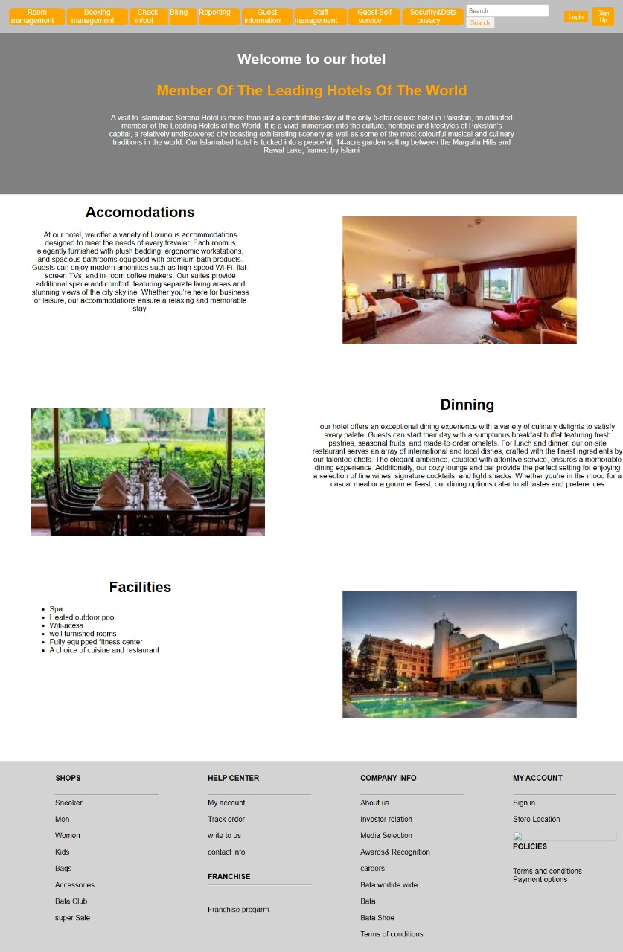

# **4. References**

* + - 1. Taj Hotels India Mumbai
         1. <https://www.tajhotels.com/en-in/epicureprogram?utm_source=google&utm_medium=cpc&utm_campaign=Pmax_epicure&gad_source=1>
      2. Pearl-Continental Hotel Lahore

b. <https://www.pchotels.com/hotel-and-resort/pearl-continental-hotel-lahore>

1. Social Science Research Network (SSRN)
   * + 1. <https://papers.ssrn.com/sol3/papers.cfm?abstract_id=4352593>